Escalator Threatened by Collapsed Shark Tank

Sharks and escalators may not be a good mix (for humans, anyway), but pedestrians need not fear any such finned intrusion such as the one claimed here.

There is a photo being passed around of sharks at the bottom of escalators. The captions say the shark tank at The Scientific Center in Kuwait collapsed.

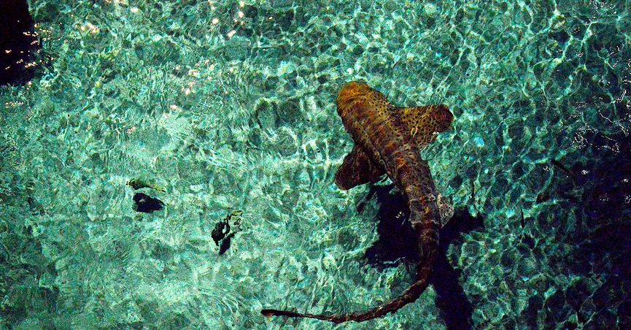

First of all, the image displayed above isn’t a photograph taken at Kuwait’s [Scientific Center](https://www.kfas.org/innovation-center/the-scientific-center" \t "_blank) (which does have a [shark tank](https://www.youtube.com/watch?v=k26EswFruWI" \t "_blank)); it’s a photo snapped at the basement retail concourse of Toronto’s Royal Bank Plaza complex, which together with the adjacent Union subway station was shut down for several hours on 1 June 2012 after it was [flooded with rainwater and sewage](http://www.cbc.ca/news/canada/toronto/story/2012/06/02/toronto-ttc-union-flooding.html" \t "_blank).

Second, no sharks were present in Union Station that day. This image is one of many Photoshop-produced [memes](http://www.cbc.ca/news/canada/toronto/story/2012/06/01/toronto-union-station-flood-meme.html" \t "_blank) that circulated on the Internet in the aftermath of the Toronto flooding incident, several of which featured sharks. The image shown above used the following original flood photo as its basis:

First of all, the image displayed above isn’t a photograph taken at Kuwait’s [Scientific Center](https://www.kfas.org/innovation-center/the-scientific-center" \t "_blank) (which does have a [shark tank](https://www.youtube.com/watch?v=k26EswFruWI" \t "_blank)); it’s a photo snapped at the basement retail concourse of Toronto’s Royal Bank Plaza complex, which together with the adjacent Union subway station was shut down for several hours on 1 June 2012 after it was [flooded with rainwater and sewage](http://www.cbc.ca/news/canada/toronto/story/2012/06/02/toronto-ttc-union-flooding.html" \t "_blank).

Second, no sharks were present in Union Station that day. This image is one of many Photoshop-produced [memes](http://www.cbc.ca/news/canada/toronto/story/2012/06/01/toronto-union-station-flood-meme.html" \t "_blank) that circulated on the Internet in the aftermath of the Toronto flooding incident, several of which featured sharks. The image shown above used the following original flood photo as its basis:

